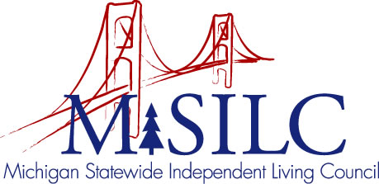

OPEN MEETINGS NOTICE
OUR VISION

To Champion systemic change creating inclusive communities across the state for all Michigan citizens.

SPIL MISSION

To promote independent living opportunities across all spheres of life.

The SILC Membership
is pleased to announce their upcoming
Special Business Meeting

December 20, 2021
Zoom Teleconference Meeting

Quarterly Business Meeting: 6:00 p.m. - 6:30 p.m.

Call In: 1-646-558-8656
Meeting ID: 883 3260 5290

Join Zoom Meeting
https://us02web.zoom.us/j/88332605290

NOTE: If you need reasonable accommodations to participate in this meeting, please contact our office at #833-808-7452 no later than Friday, December 17, 2021.

